Optimizing Sales and Inventory Management in Retail & Wholesale

Business Context
Effective inventory and sales management is crucial for profitability in the retail and wholesale sectors. Companies often face losses due to inefficient pricing strategies, poor inventory turnover, or overdependence on select vendors. This analysis aims to identify performance inefficiencies and uncover actionable insights to boost profitability and operational efficiency.

Project Objectives
- Identify underperforming brands requiring promotional or pricing adjustments.
- Determine top vendors driving sales and gross profit.
- Analyze the impact of bulk purchasing on unit costs.
- Assess inventory turnover to reduce holding costs and improve efficiency.
- Compare profitability between high-performing and low-performing vendors.

Exploratory Data Analysis (EDA)

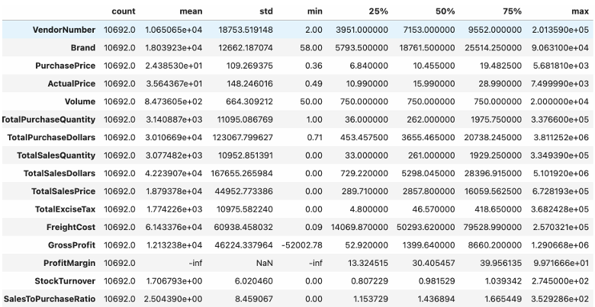

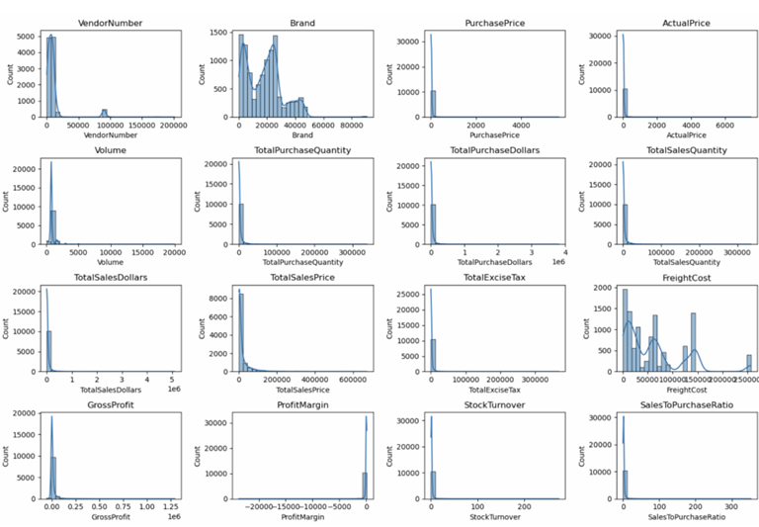

Summary Statistics & Outlier Detection
Metric | Key Insight
Gross Profit | Minimum of -52,002.78 suggests potential losses from poor pricing or excessive discounts.
Profit Margin | Includes negative and extreme values (e.g., -∞), likely due to zero or negative revenue.
Sales Quantity & Sales Revenue | Zero values indicate unsold inventory—potential slow-moving or obsolete stock.
Price Metrics | Purchase (Max: 5,681.81) & Actual Price (Max: 7,499.99) have wide ranges, indicating premium products.
Freight Costs | Huge variability (0.09 to 257,032.07), possibly from inconsistent shipping practices or large bulk orders.
Stock Turnover | Ranges from 0 to 274.5. High values suggest rapid movement; 0 indicates stagnant inventory.

Data Cleaning Filters
To ensure insights are based on meaningful transactions, the following filters were applied:
- Gross Profit > 0
- Profit Margin > 0
- Sales Quantity > 0

Correlation Analysis

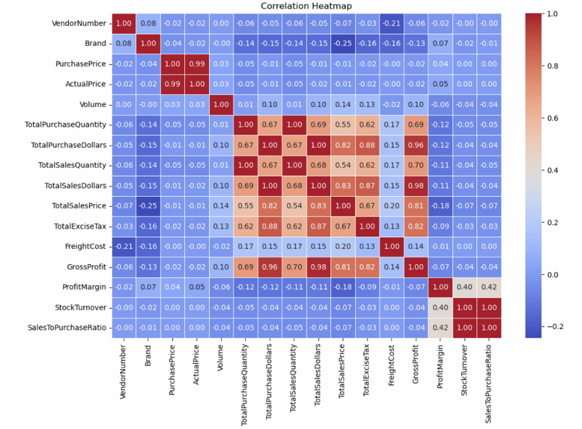

Variable Pair | Correlation | Interpretation
Purchase Price vs. Sales/Gross Profit | ~ -0.01 | Price doesn’t significantly affect revenue or profit.
Purchase Quantity vs. Sales Quantity | 0.999 | Strong indication of effective inventory flow.
Profit Margin vs. Sales Price | -0.179 | Higher sales prices can reduce margin due to discounting or market pressures.
Stock Turnover vs. Profitability | ~ -0.05 | Faster turnover doesn't always mean higher profit.

Research Questions & Key Findings

Which Brands Need Promotional or Pricing Adjustments?
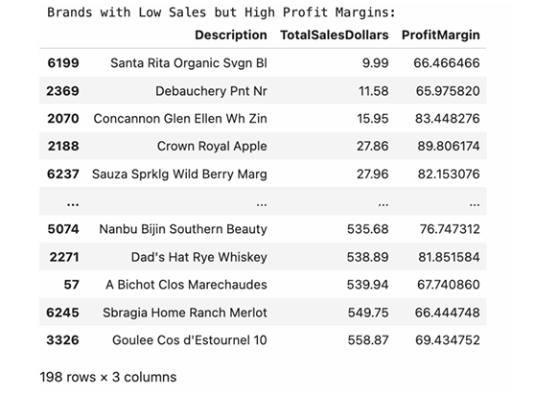
- 198 brands have low sales but high margins.
- Opportunity to increase volume through promotions or optimized pricing.

Who Are the Top Vendors by Purchase Contribution?
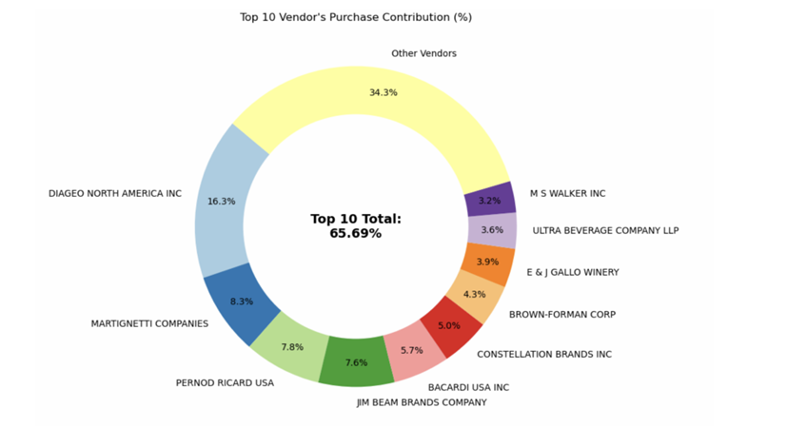
- Top 10 vendors account for 65.69% of total purchases.
- Remaining 34.31% from others indicates vendor concentration risk.
- Calls for diversification to mitigate disruptions.

Does Bulk Purchasing Lower Unit Costs?
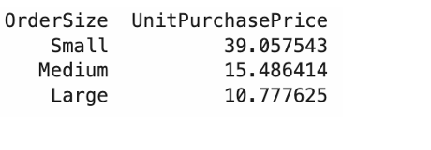
- Large-volume buyers enjoy unit cost savings of ~72% ($10.78 vs. higher small-order rates).
- Bulk pricing strategies support cost-effective growth.

Which Vendors Have Low Inventory Turnover?

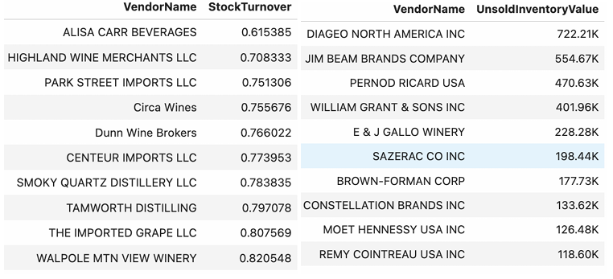
- Unsold Inventory Value: $2.71M
- Indicates capital lock-in, high holding costs, and reduced cash flow.
- Identifying such vendors can help optimize reorder quantities and minimize waste.

5. Do Profit Margins Differ by Vendor Type?
- Vendor Type | - 95% Confidence Interval | - Mean Margin
- Top-Selling Vendors | - (30.74%, 31.61%) | - 31.17%
- Low-Performing Vendors | - (40.48%, 42.62%) | - 41.55%
- Low-performers have higher margins but struggle with sales, implying pricing inefficiencies or weak market reach.

Are the Margin Differences Statistically Significant?

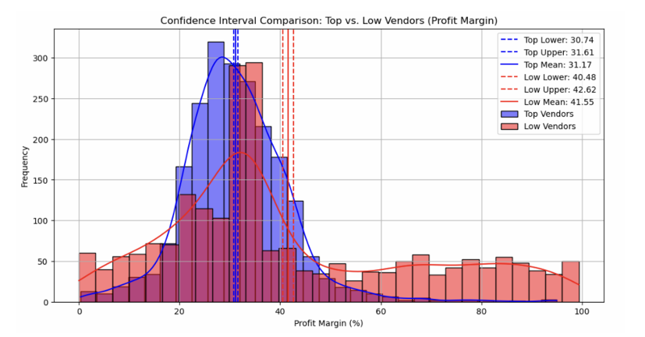

Hypothesis:
- H₀: No difference in margins between top and low-performing vendors.
- H₁: There is a significant difference.

Result:
- H₀ is rejected (based on statistical test).
- Confirms distinct profitability models between vendor groups.

Actionable Recommendations
Focus Area | Recommendations
Brand Strategy | Reprice or promote low-sales/high-margin brands to boost volume without hurting profit.
Vendor Management | Diversify vendor base to reduce dependency on top 10 contributors.
Purchasing Strategy | Expand bulk purchasing to maximize unit cost savings and improve margins.
Inventory Management | Target slow movers via clearance, smarter purchasing, or improved forecasting.
Low-Performing Vendors | Enhance marketing reach, revise pricing, and explore bundling to drive sales.

Vendor Performance Power BI Dashboard

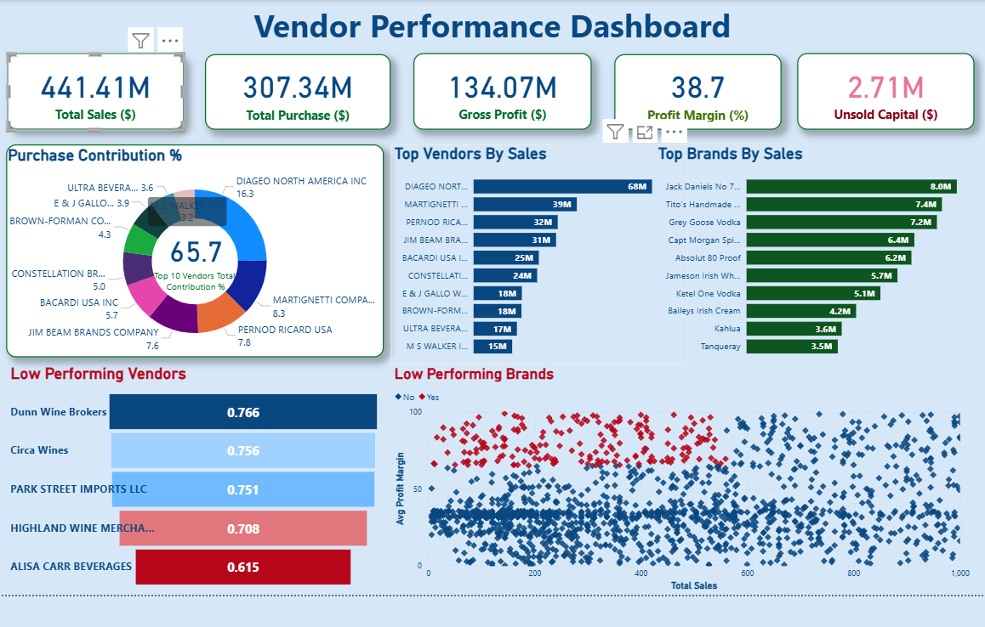

Key Insights
- The top vendor, Diageo North America Inc, alone contributes $68M in sales, followed by Martignetti Company ($39M) and Pernod Ricard USA ($32M).

- Collectively, the top 10 vendors contribute 65.7% of the total purchase value, showing a high dependency on a few major suppliers.

- The business maintains a 38.7% profit margin on total sales of $441.41M, resulting in a $134.07M gross profit.

- Leading brand sales are relatively smaller in scale, with Jack Daniels No.7 at $8M, followed by Tito’s Handmade Vodka ($7.4M) and Grey Goose Vodka ($7.2M).

